**WEEK 6 MANDATORY HANDS-ON**

**REACT :**

1. Create a new React Application with the name “myfirstreact”, Run the application to print “welcome to the first session of React” as heading of that page.

Code:

***#App.css:***

.App {

text-align: center;

}

.App-logo {

height: 40vmin;

pointer-events: none;

}

@media (prefers-reduced-motion: no-preference) {

.App-logo {

animation: App-logo-spin infinite 20s linear;

}

}

.App-header {

background-color: #282c34;

min-height: 100vh;

display: flex;

flex-direction: column;

align-items: center;

justify-content: center;

font-size: calc(10px + 2vmin);

color: white;

}

.App-link {

color: #61dafb;

}

@keyframes App-logo-spin {

from {

transform: rotate(0deg);

}

to {

transform: rotate(360deg);

}

}

***#App.js:***

function App() {

return (

<div>

<h1>Welcome to the first session of React</h1>

</div>

);

}

export default App;

***#App_test.js:***

import { render, screen } from '@testing-library/react';

import App from './App';

test('renders learn react link', () => {

render(<App />);

const linkElement = screen.getByText(/learn react/i);

expect(linkElement).toBeInTheDocument();

});

***#index.css:***

body {

margin: 0;

font-family: -apple-system, BlinkMacSystemFont, 'Segoe UI', 'Roboto', 'Oxygen',

'Ubuntu', 'Cantarell', 'Fira Sans', 'Droid Sans', 'Helvetica Neue',

sans-serif;

-webkit-font-smoothing: antialiased;

-moz-osx-font-smoothing: grayscale;

}

code {

font-family: source-code-pro, Menlo, Monaco, Consolas, 'Courier New',

monospace;

}

***#index.js:***

import React from 'react';

import ReactDOM from 'react-dom/client';

import './index.css';

import App from './App';

import reportWebVitals from './reportWebVitals';

const root = ReactDOM.createRoot(document.getElementById('root'));

root.render(

<React.StrictMode>

<App />

</React.StrictMode>

);

// If you want to start measuring performance in your app, pass a function

// to log results (for example: reportWebVitals(console.log))

// or send to an analytics endpoint. Learn more: https://bit.ly/CRA-vitals

reportWebVitals();

Output:

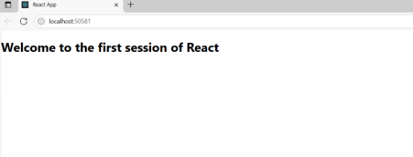

2. Create a react app for Student Management Portal named StudentApp and create a component named Home which will display the Message “Welcome to the Home page of Student Management Portal”. Create another component named About and display the Message “Welcome to the About page of the Student Management Portal”. Create a third component named Contact and display the Message “Welcome to the Contact page of the Student Management Portal”. Call all the three components.

Code:

***#App.js:***

import React from 'react';

import Home from './Components/Home';

import About from './Components/About';

import Contact from './Components/Contact';

function App() {

return (

<div>

<Home />

<About />

<Contact />

</div>

);

}

export default App;

EXTRA COMPONENTS FOR ABOUT, CONTACT, HOME APART FROM FIRST PROGRAM:

***#About.js:***

import React from 'react';

function About() {

return (

<div>

<h2>Welcome to the About page of the Student Management Portal</h2>

</div>

);

}

***#Contact.js:***

import React from 'react';

function Contact() {

return (

<div>

<h2>Welcome to the Contact page of the Student Management Portal</h2>

</div>

);

}

export default Contact;

***#Home.js:***

import React from 'react';

function Home() {

return (

<div>

<h2>Welcome to the Home page of Student Management Portal</h2>

</div>

);

}

export default Home;

Output:

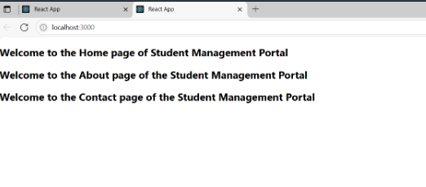

3. Create a react app for Student Management Portal named scorecalculatorapp and create a function component named “CalculateScore” which will accept Name, School, Total and goal in order to calculate the average score of a student and display the same.

Code:

***#App.js:***

import React from 'react';

import CalculateScore from './Components/CalculateScore';

function App() {

return (

<div className="App">

<CalculateScore name="Shafreen" school="Sri Chaitanya Techno School" total={450} goal={5} />

</div>

);

}

export default App;

EXTRA COMPONENTS:

***#CalulateScore,js:***

import React from 'react';

import '../Stylesheets/mystyle.css';

function CalculateScore(props) {

const { name, school, total, goal } = props;

const average = total / goal;

return (

<div className="score-card">

<h2>Student Score Report</h2>

<p><strong>Name:</strong> {name}</p>

<p><strong>School:</strong> {school}</p>

<p><strong>Total Marks:</strong> {total}</p>

<p><strong>Goals:</strong> {goal}</p>

<p><strong>Average Score:</strong> {average.toFixed(2)}</p>

</div>

);

}

export default CalculateScore;

Extra Styles used:

.score-card {

background-color: #f2f2f2;

padding: 20px;

margin: 30px auto;

width: 400px;

border-radius: 10px;

box-shadow: 0 0 10px rgba(0,0,0,0.1);

font-family: Arial, sans-serif;

}

.score-card h2 {

text-align: center;

color: #333;

}

.score-card p {

font-size: 16px;

line-height: 1.5;

}

Output: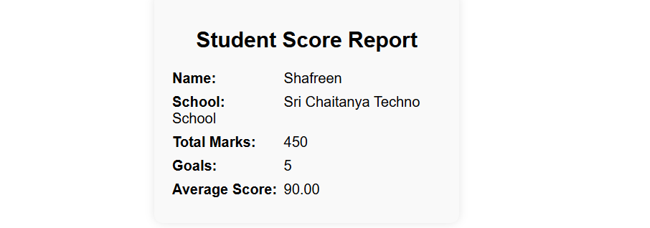

4. Code:

EXTRA COMPONENTS:

***#Post.js:***

class Post {

constructor(id, title, body) {

this.id = id;

this.title = title;

this.body = body;

}

}

export default Post;

***#Posts.js:***

import React, { Component } from 'react';

class Posts extends Component {

constructor(props) {

super(props);

this.state = {

posts: [],

hasError: false

};

}

loadPosts() {

const samplePosts = [

{

id: 1,

title: "How to Get Started with React",

body: "React is a powerful JavaScript library for building user interfaces..."

},

{

id: 2,

title: "Understanding Component Lifecycle",

body: "React components go through various lifecycle phases such as mounting..."

},

{

id: 3,

title: "Using Fetch API in React",

body: "The Fetch API lets you load data asynchronously in React components..."

}

];

this.setState({ posts: samplePosts });

}

componentDidMount() {

this.loadPosts();

}

componentDidCatch(error, info) {

console.error("Caught error:", error, info);

alert("Something went wrong while loading the posts.");

this.setState({ hasError: true });

}

render() {

if (this.state.hasError) {

return <h2>Unable to load posts. Please try again later.</h2>;

}

return (

<div>

<h1>Blog Posts</h1>

{this.state.posts.map(post => (

<div key={post.id}>

<h3>{post.title}</h3>

<p>{post.body}</p>

<hr />

</div>

))}

</div>

);

}

}

export default Posts;

Output:

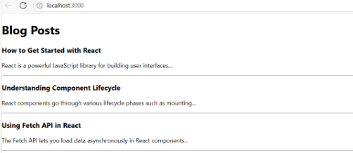

5. Code:

EXTRA COMPONENTS:

***#CohortDetails.css:***

.box {

width: 300px;

display: inline-block;

margin: 10px;

padding: 10px 20px;

border: 1px solid black;

border-radius: 10px;

}

dt {

font-weight: 500;

}

***#CohortDetails.js:***

import React from 'react';

import styles from './CohortDetails.module.css';

function CohortDetails({ name, startDate, endDate, status }) {

const headingStyle = {

color: status === 'ongoing' ? 'green' : 'blue'

};

return (

<div className={styles.box}>

<h3 style={headingStyle}>{name}</h3>

<dl>

<dt>Start Date:</dt>

<dd>{startDate}</dd>

<dt>End Date:</dt>

<dd>{endDate}</dd>

<dt>Status:</dt>

<dd>{status}</dd>

</dl>

</div>

);

}

export default CohortDetails;

Output:

